# ASSIGNMENT NO-15

* **Problem Statement:- Create serverless computing service.**
* **Steps:**-
  + **Create Lambda function:-**

1. In search tab type **Lambda.** And it willopen the following page.

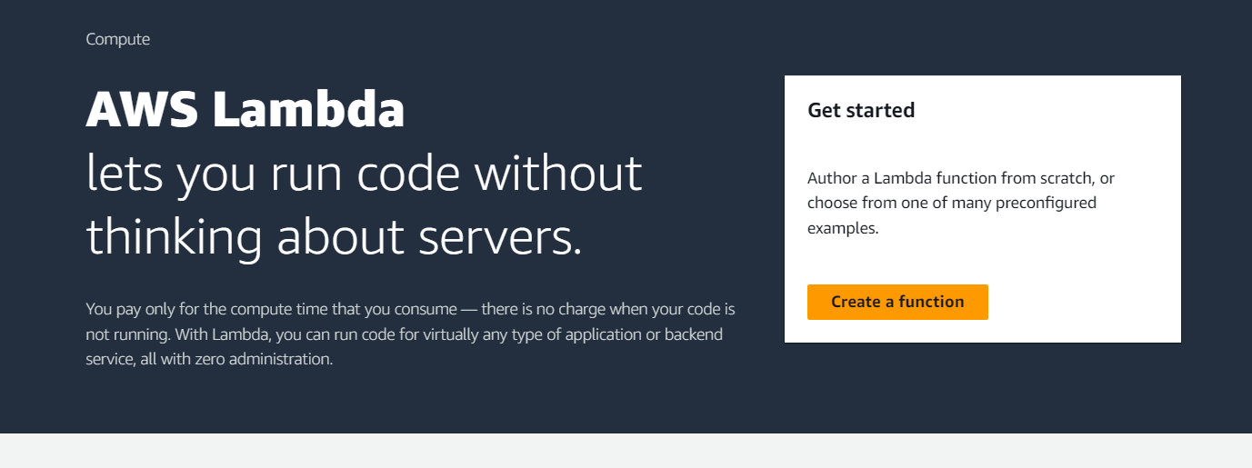

1. click **create a function**. Select “author from scratch” ,type the func name(ex-func1),runtime user choice(here-Node.js 18.x) and click Create function.

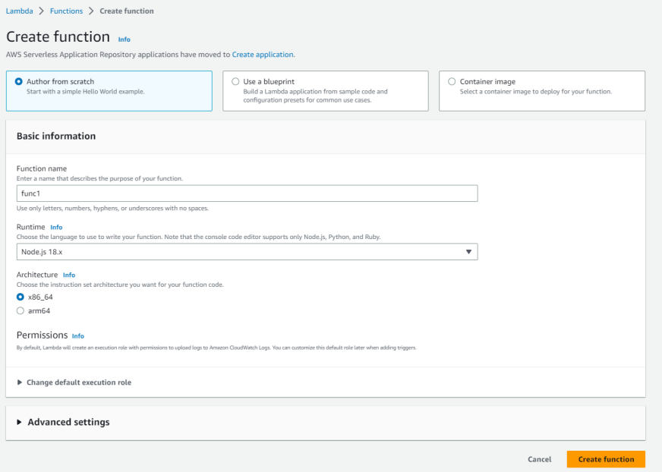

In func1, scroll down and go to code section. And edit the index.js file.and save it and deploy.

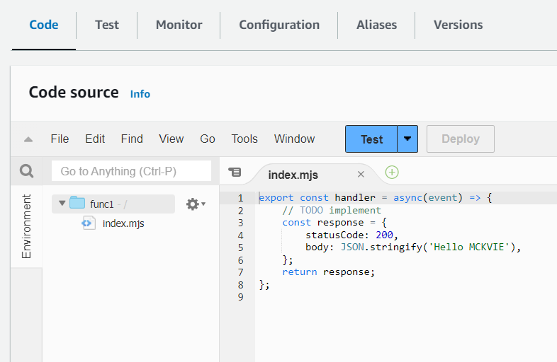

Now, goto configuration and in the left side select “**function url”.** Click create function url.

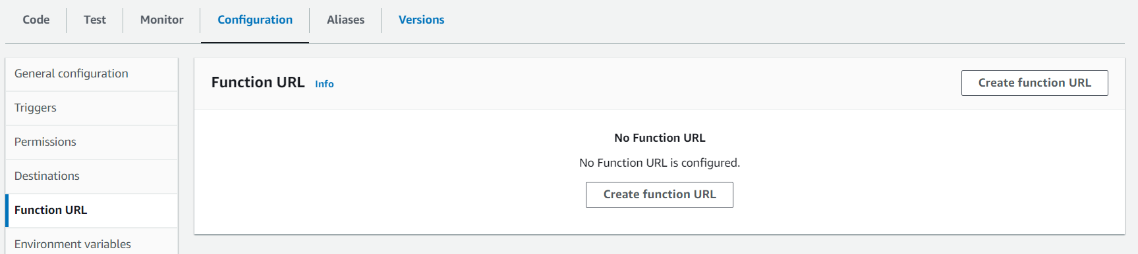

In function url,select NONE. And click save.

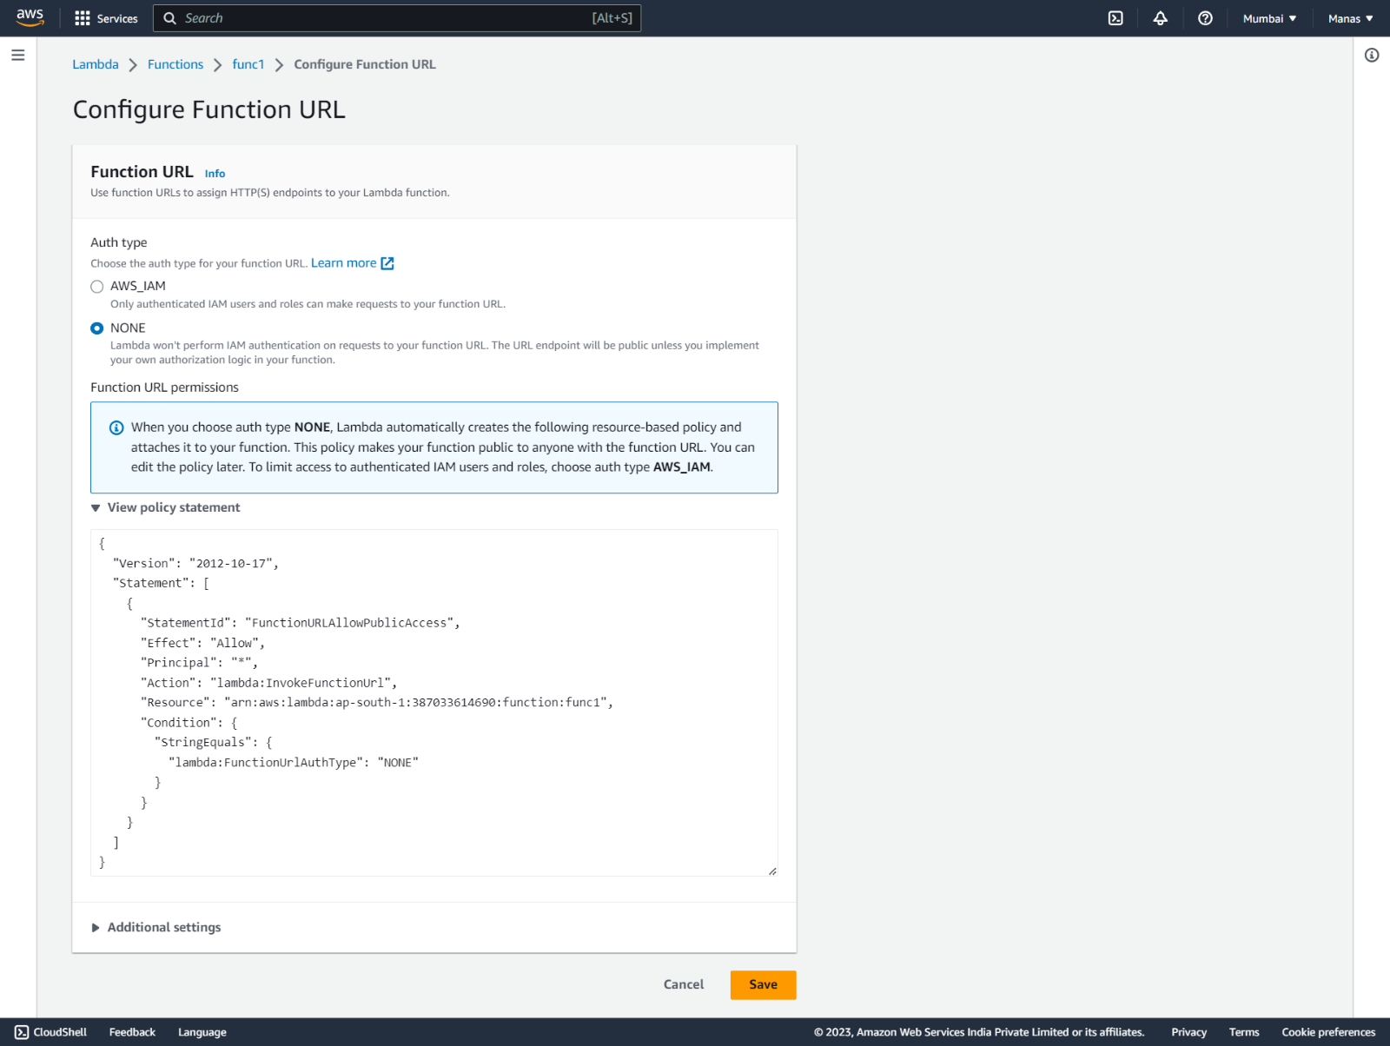

Now copy the function URL and paste it new tab and we can see that its running.

